Event Title | Expert Lecture on Entrepreneurship
Event Date and Time | 18th June 2022, 9:00AM – 10:00AM
Venue | Block C Auditorium
No. of students attending the event | Approx. 60 students

Event Report

Detailed report
The Entrepreneurship Cell of Nirma University had organized an expert guest lecture on Entrepreneurship on 18th June 2022. The purpose of this event is to make students aware about the entrepreneurship journey, its challenges and how one can get started with their start-up journey. This event was aimed at motivating students as well as providing valuable information.
The event was an hour-long event from 9:00am – 10:00am. The students were expected to be in their formal uniform. Approximately 60 students attended the session. The event went on with the following order: -
- Introduction speech
- Expert lecture
- A token of thanks
- Closing speech
The expert lecturer for today was Dr. Krupa Mehta. She is a young enthusiastic individual with a good academic background. She is the president of the Gujarat start-up council of Women’s Indian chamber of commerce and industry and Co-convenor of MSME and start-up forum – Bharat. She is assistant professor at S. K. Patel institute of management and computer studies, MBA (SKPIMCS). She talked about how to get started with entrepreneurial journey, the importance of entrepreneurship and how one can progress in this path. She also talked about design thinking and made us aware of how small opportunities have become billion-dollar businesses. She also motivated the students to think big and go ahead with the ideas and strive them to make it a reality. The event was full of useful learnings and motivation.
Prof. Vishal Goel and Prof, Rashmika Shah was also present in the event. The memento was presented by Vishal Goel sir to the guest.

Photos
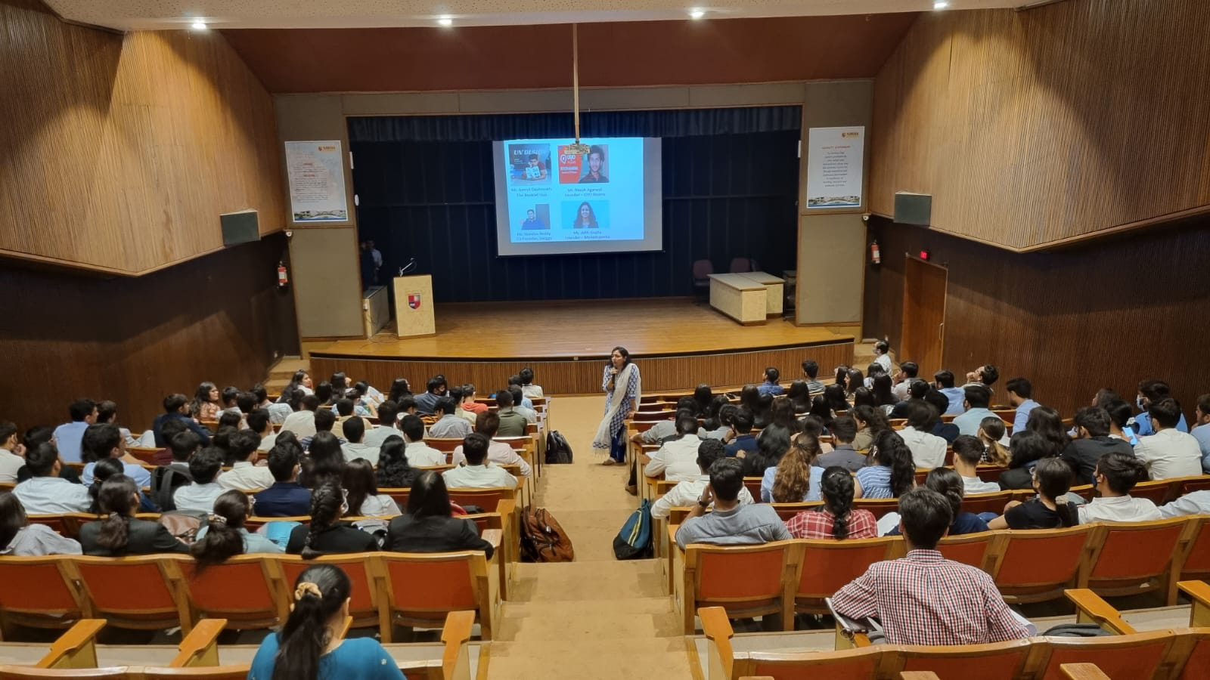
(Picture – 1: Students listening to the guest lecturer)
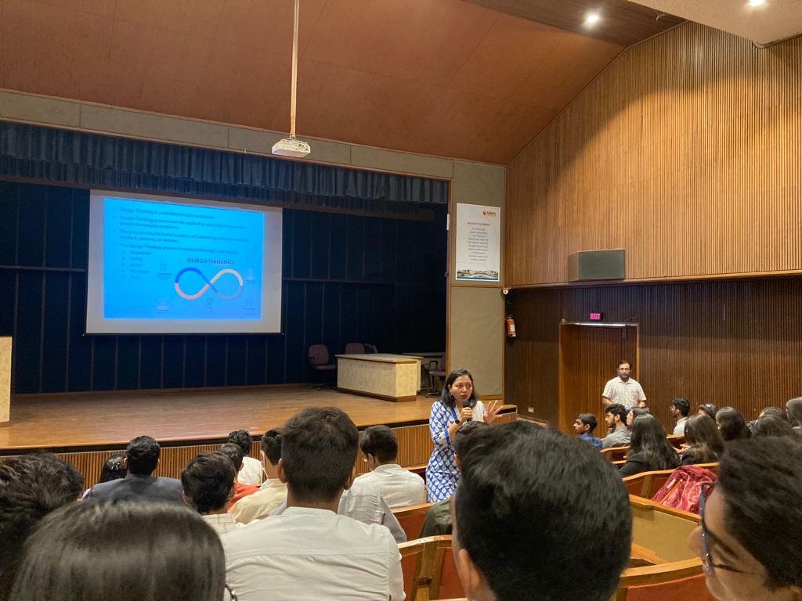
(Picture 2: Students interacting with the guest lecturer)

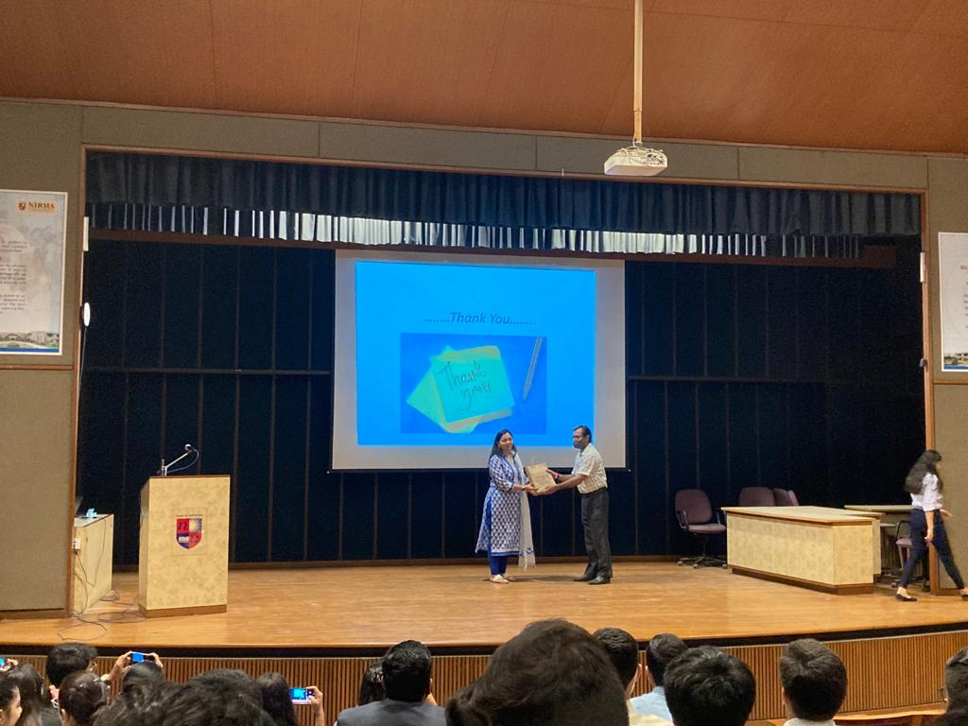
(Picture – 3: Dr. Krupa Mehta receiving memento from Prof. Vishal Goel)

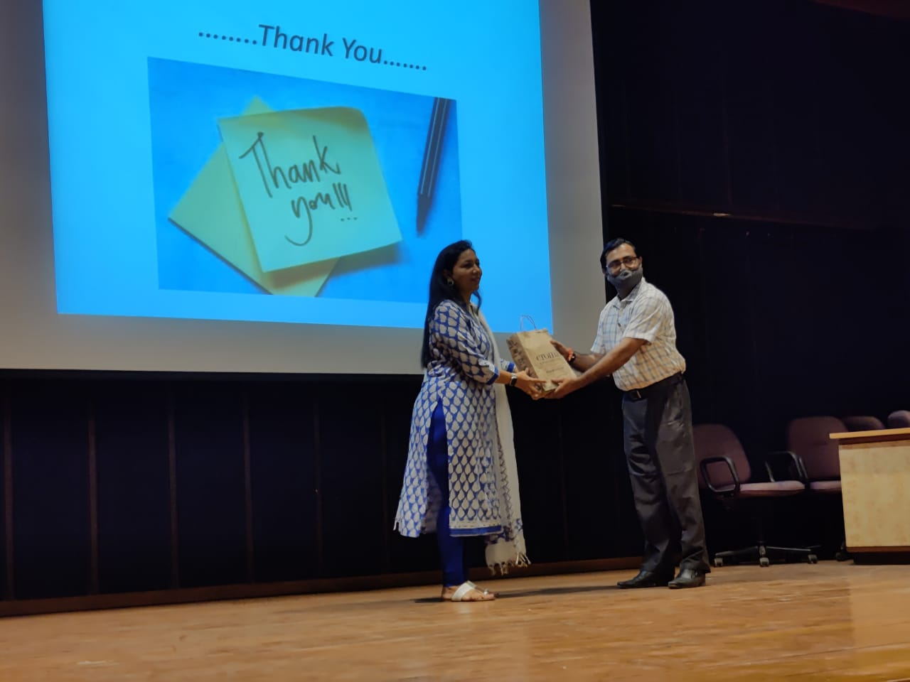
(Picture – 4: Dr. Krupa Mehta receiving memento from Prof. Vishal Goel)
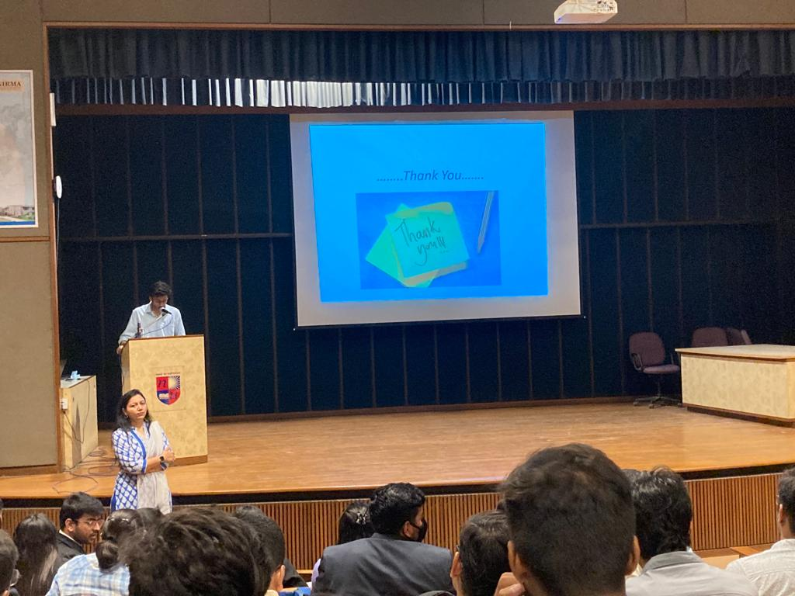
(Picture – 5: Student ending the event with a vote of thanks)

